**Survey Genie User Manual**

**Table of Contents**

1. Getting Started
   * System Requirements
   * Installation
   * Registration
2. Overview of the Interface
   * User classification
   * Screens offered
   * Dashboard
   * Manage
   * Account
   * Reports
   * Recommendation
3. Using Survey Genie
   * 3.1 Guide to create LEVEL-1
   * 3.2 Guide to create LEVEL-2
   * 3.3 Guide to create QUESTION
   * 3.4 Guide to create ANSWER
   * 3.5 Guide to create SURVEY
   * 3.6 Guide to SURVEY-CLIENT MAPPING
   * 3.7 Guide to SURVEY-USER MAPPING
   * 3.8 Guide to SURVEY- LEVEL-1 MAPPING
   * 3.9 Guide to check QUESTIONS MAPPED TO SURVEY
   * 3.10 Guide to ANSWER THE QUESTIONS IN A SURVEY
   * 3.11 Guide to access USER REPORT OF A SURVEY
   * 3.12 Guide to access ORGANIZATION REPORT
   * 3.13 Guide to access BENCHMARK REPORT
   * 3.14 Guide to create RECOMMENDATION
   * 3.15 Guide to create SCORE-RANGE MASTER
   * 3.16 Guide to map SCORE-RANGE – RECOMMENDATION
   * 3.17 Guide to map CATEGORY - SCORE-RANGE
   * 3.18 Guide to map SURVEY - SCORE-RANGE
   * 3.19 Guide to ANSWER THE QUESTIONS IN AN OPEN SURVEY
   * 3.20 Guide to access OPEN SURVEY REPORT

**1.** **Getting Started**

**System Requirements**

* Operating System: Windows 10 or later, macOS 10.13 or later
* Browser: Latest version of Chrome, Firefox, Safari, or Edge
* Internet Connection: Stable broadband connection

**Installation**

Survey Genie is a web-based application, so there is no need for installation. Simply visit <https://alumni.thejourney36.com/apps/view/survey-genie> to get started.

**Registration**

Upon registering your organisation with Alumni Services via the “Clients” application, a user ID and password will be generated and sent to you by E-mail. Please use this credentials to login to the Survey Genie application

**2.** **Overview of the Interface**

**User classification**

Within Survey Genie, users are classified into 3 types based on their roles:

* Super-Admin: An employee from Alumni Service who will be accessing all dashboards, has complete control Survey creation and assignment.
* External Admin: The admin of the external organisation that is trying to gain insights by using survey genie
* External Employee: The employee of the external organisation who will respond to the survey assigned to them.

Based on this classification, the access is differentiated in the application.

**Screens offered:**

The following table shows the screens mapped to the specific roles.

|  |  |  |  |
| --- | --- | --- | --- |
|  | **Super admin** | **External Admin** | **External Employee** |
| Admin Dashboard | ✓ | ✓ |  |
| Employee Dashboard |  |  | ✓ |
| Level-1 | ✓ |  |  |
| Question | ✓ |  |  |
| Survey | ✓ |  |  |
| Organisations | ✓ |  |  |
| My Survey | ✓ | ✓ | ✓ |
| Attempted Survey | ✓ | ✓ | ✓ |
| Benchmark Report | ✓ | ✓ |  |
| Organisation Report | ✓ | ✓ |  |
| Recommendation Master | ✓ |  |  |
| Score Range Manager | ✓ |  |  |
| Open Users List | ✓ |  |  |

**Dashboard**

The dashboard is your main hub for navigating Survey Genie. Here you can:

* View recent surveys
* Access analytics

**Manage**

This section allows you to create the masters to begin making surveys. This section consists of:

* Level-1
* Questions
* Survey
* Organizations

**Account**

The account section has the access that all users have to their surveys. This section contains:

* My Survey
* Attempted Surveys

**Reports**

This section has the organisation and benchmark report that can be used by Super admin and external admin users to avail insights from the surveys

**Recommendation**

Based on the average achieved by a user or organisation in a survey or category, specific pre-defined text is shown to the user. This is achieved by mapping a recommendation text to a score set and the score set is mapped to the survey/category to be displayed.

**3.** **Using Survey Genie**

Before we create a survey, there are certain sub-masters to be created to support the survey.

**3.1** **Guide to create LEVEL-1**

1. Click on "Level-1" under “Manage”.
2. Click on the “New” button above the grid.
3. Enter the name, alias name, description, and status(“active”, “inactive”)
4. Click on “Save” button.

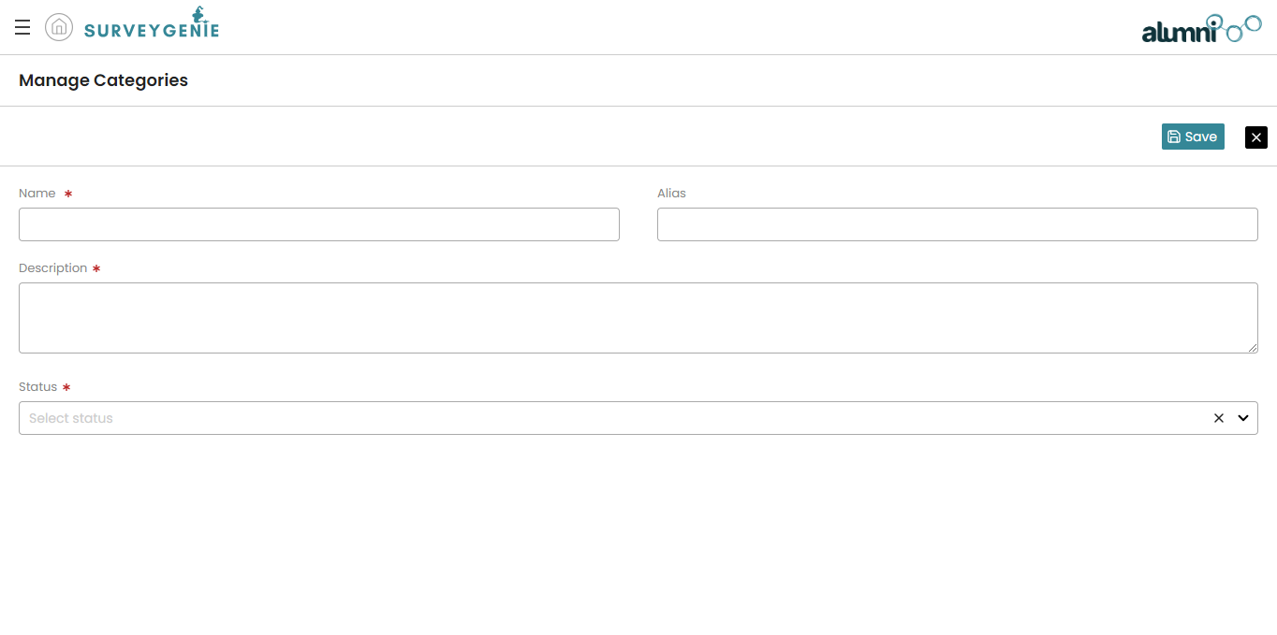

**3.2** **Guide to create LEVEL-2:**

1. Click on "Level-1" under “Manage”.
2. Click on the edit icon against the Level-1 that you want to map the Level-2 to.
3. Click on the “Level-2” tab and a grid will be shown.
4. Click on the “new” button above the grid.
5. Enter the name, description, and status(“active”, “inactive”)
6. Click on the “Submit”

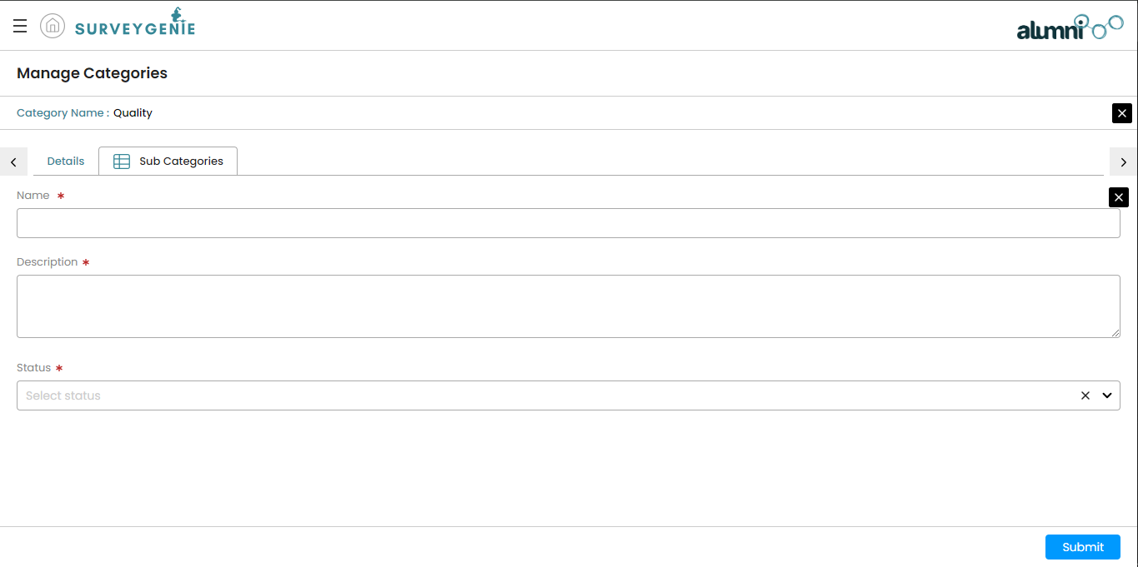

**3.3** **Guide to create QUESTION:**

1. Click on "Questions" under “Manage”.
2. Click on the “New” button above the grid.
3. Enter the Level-1 against which the question is to be mapped.
4. Enter the Level-2 against which the question is to be mapped.
5. Enter the type as single choice.
6. Enter the question.
7. If the question is mandatory, tick the isRequired checkbox.
8. Click on “Save” to save your question.

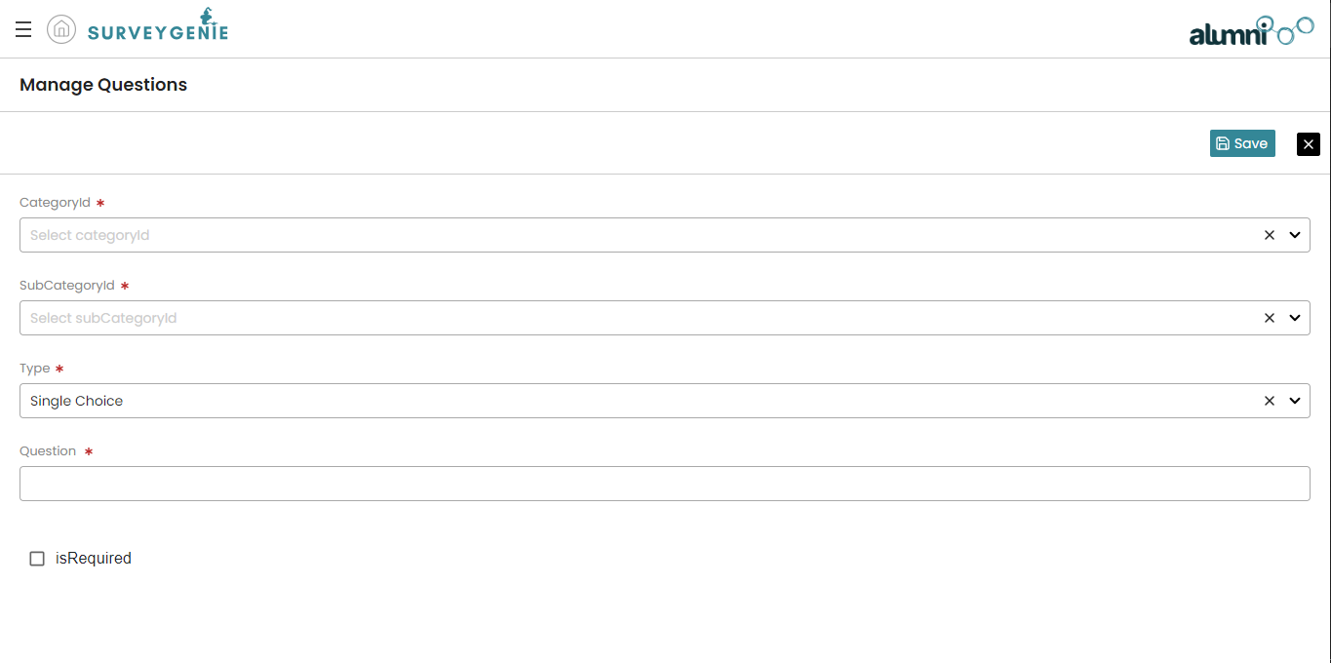

**3.4** **Guide to create ANSWER:**

1. Click on "Questions" under “Manage”.
2. Click on the edit icon against the question that you want to map the answer to.
3. Click on the “Answers” tab and a grid will be shown.
4. Click on the “new” button above the grid.
5. Enter the Answer and score that you want to assign to the answer
6. If you want to assign the answer as correct, tick the isCorrect checkbox

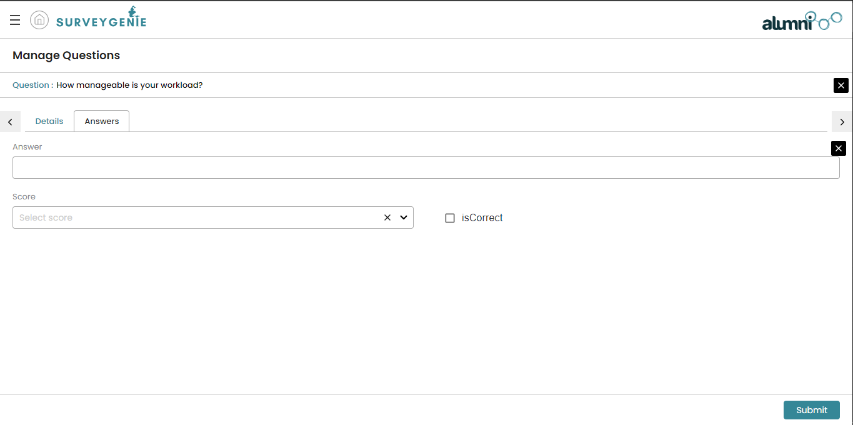

**Now that we have created all the required sub-masters, let’s create the survey**

**3.5** **Guide to create SURVEY:**

1. Click on "Survey" under “Manage”.
2. Click on the “New” button above the grid.
3. Enter the Title, start date, end date, description and the status of the survey.
4. Attach the thumbnail image and banner image for the survey to display it at the beginning of the survey when it is attempted.
5. Check the “isOpen” check box to set the survey as open so that any user without a login can attend the survey.
6. Click on “Save” to save your Survey.

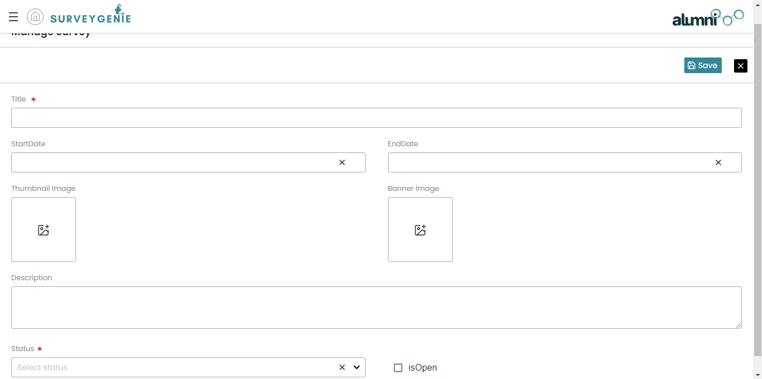

**Now, we will have to map the questions, clients and users to the survey to provide access to the users.**

**3.6** **Guide to SURVEY-CLIENT MAPPING:**

1. Click on "Survey" under “Manage”.
2. Click on the edit icon against the survey that you want to configure.
3. Click on the client mapping tab to access the mapping screen.
4. Click the plus icon against the Name of the client to assign the survey to all users of that client.

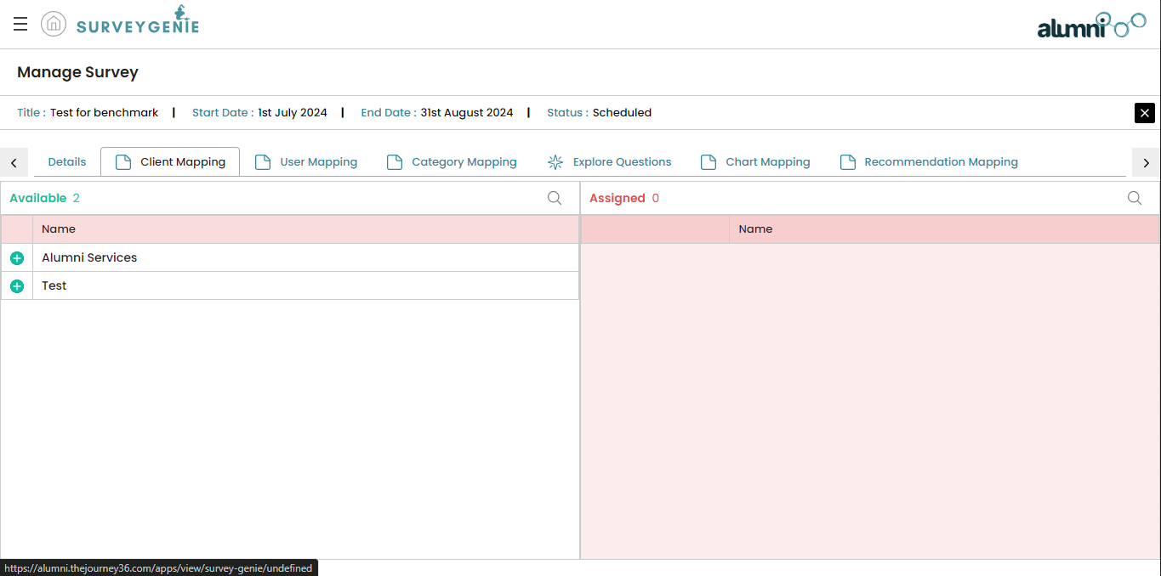

**3.7** **Guide to SURVEY-USER MAPPING:**

1. Click on "Survey" under “Manage”.
2. Click on the edit icon against the survey that you want to configure.
3. Click on the user mapping tab to access the mapping screen.
4. Click the plus icon against the Name of the user to assign the survey to users that are not mapped by client mapping.

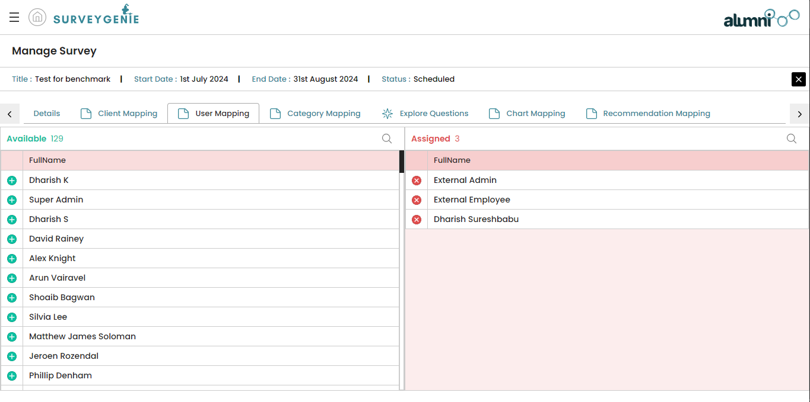

**3.8** **Guide to SURVEY-LEVEL-1 MAPPING:**

1. Click on "Survey" under “Manage”.
2. Click on the edit icon against the survey that you want to configure.
3. Click on the Level-1 mapping tab to access the mapping screen.
4. Click the plus icon against the Level-1 to assign the questions to the survey. The questions mapped to the Level-1 will be displayed while attempting the survey.

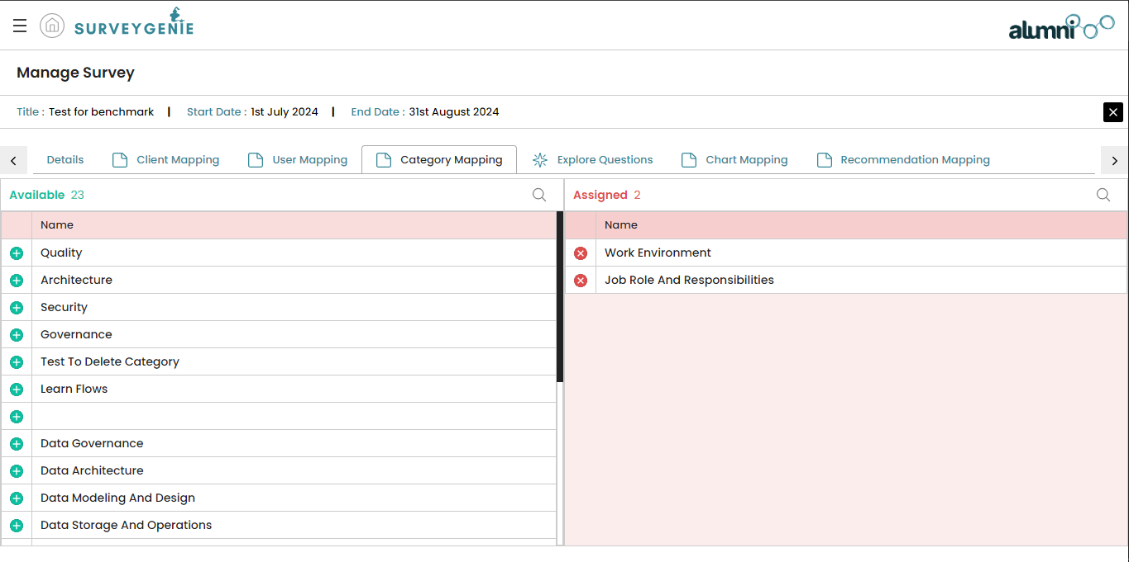

**3.9 Guide to check QUESTIONS MAPPED TO SURVEY:**

1. Click on "Survey" under “Manage”.
2. Click on the edit icon against the survey that you want to configure.
3. Click on the explore questions tab to view the questions mapped to the survey via the Level-1 mapping action.

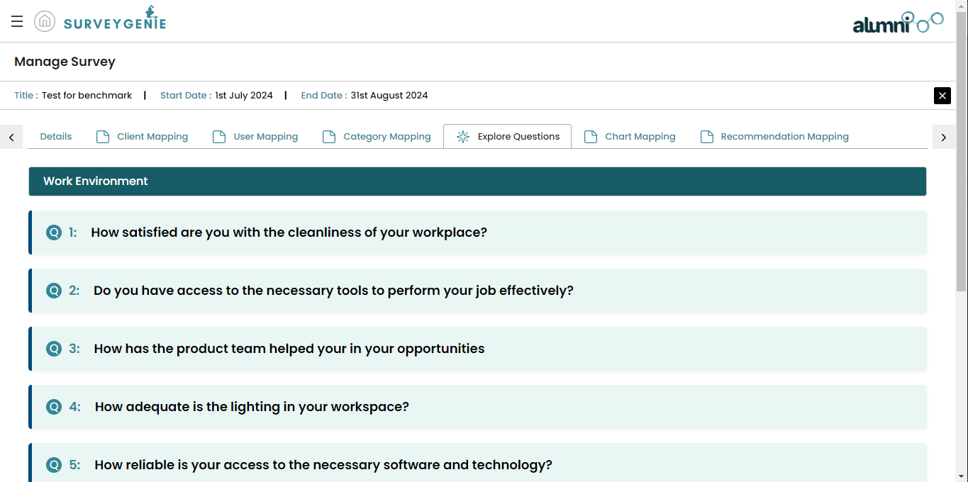

**Now that we have mapped the questions, clients and users to the survey, let’s try answering the survey.**

**3.10** **Guide to ANSWER THE QUESTIONS IN A SURVEY:**

1. Click on "My Survey" under “Account”. The list of Surveys mapped to the user will be listed.
2. Click on the survey name that you would want to attend. Three links will be shown after this.
3. Click the “Launch Survey” to start the Survey.
4. A new screen will be launched with a start survey button. Click on it to start the survey.

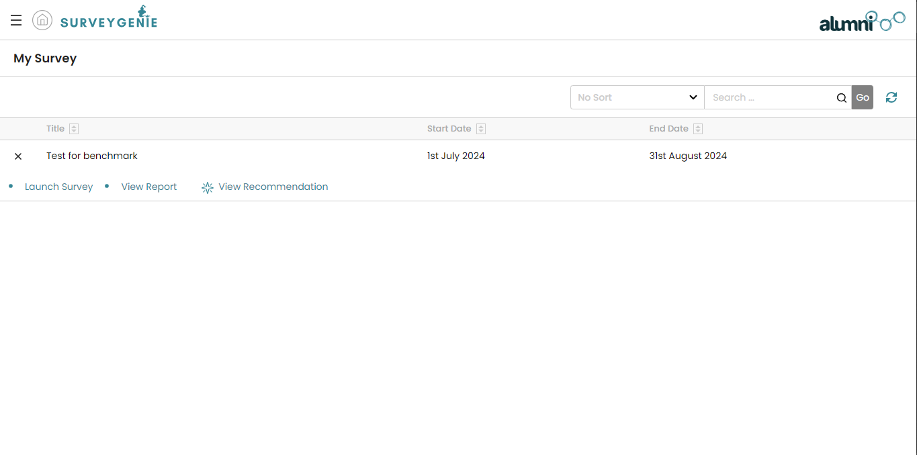

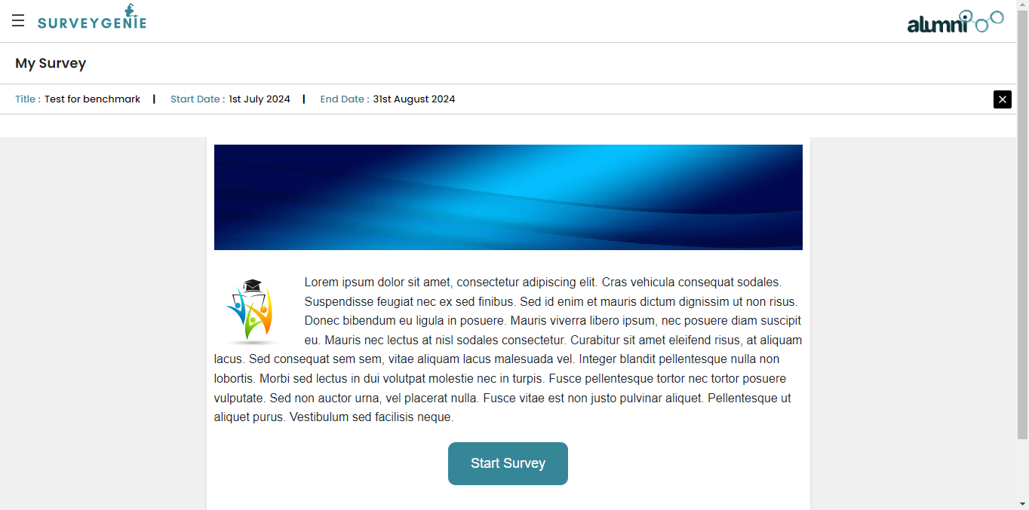

1. The survey will open up to show the first Level-1 and the questions in it. Click on the preferred option and move on to the next question.
2. After you complete the Level-1, click on the next button to save the answers to this Level-1 and move to the next Level-1.
3. After completing all the Level-1, the final next button will save all the answers and end the survey.

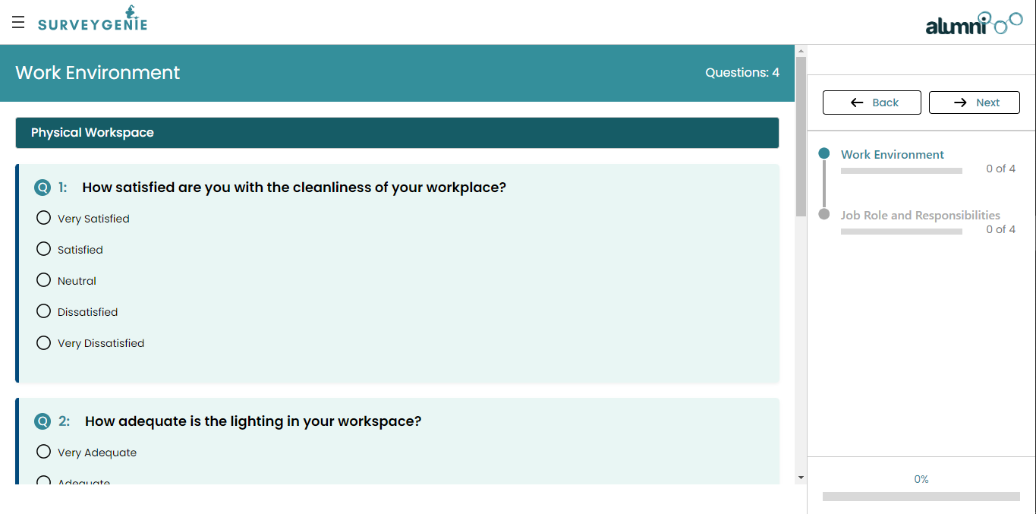

**After attempting the survey, Admins and employees can view and extract the results from individual surveys.**

**3.11** **Guide to access USER REPORT OF A SURVEY:**

1. Click on "My Survey" under “Account”. The list of Surveys mapped to the user will be listed.
2. Click on the survey name that you would want to attend. Three links will be shown after this.
3. Click the “View report” link to access the user report of that survey for that particular user.
4. The user’s average score can be seen inside a box below the My Report tab.
5. Clicking on this box will reveal the scores attained by the user against each question in the Level-1.
6. Below that a series of charts will be displayed to visualise the scores of the user against the Level-1 that they have answered to.
7. Clicking on the green download icon in the top right corner will export the data into CSV.

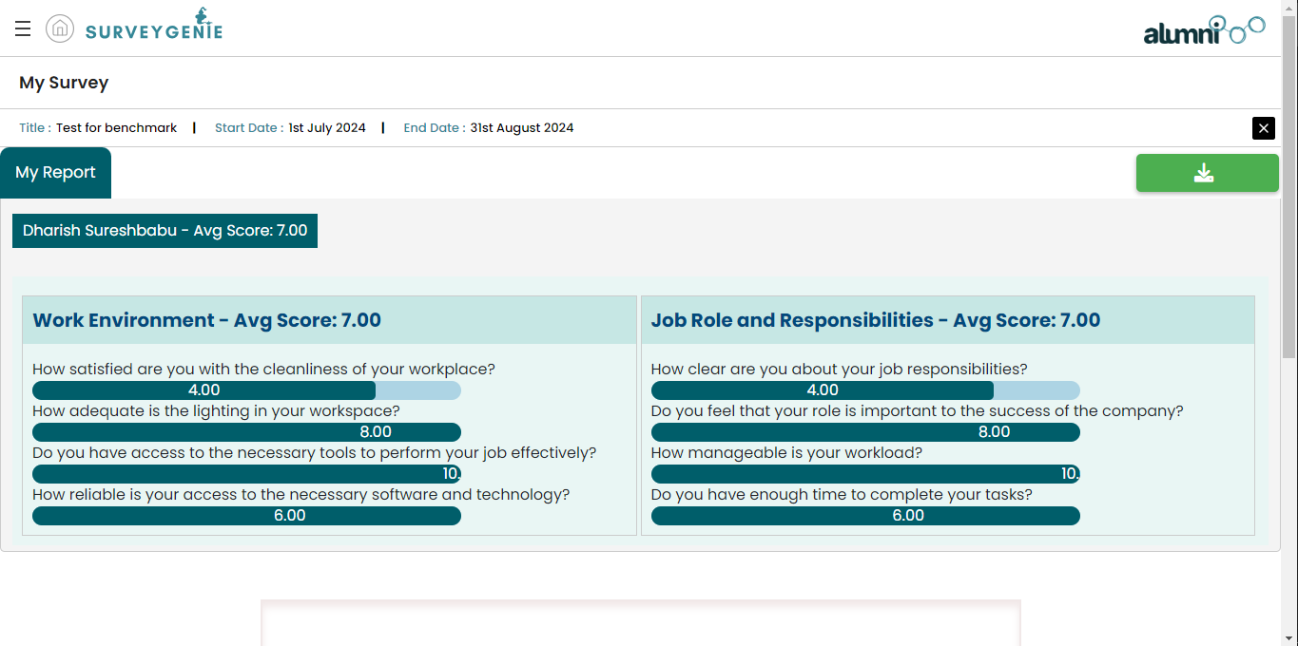

**3.12** **Guide to access ORGANIZATION REPORT:**

1. Click on "Organization report" under “Report”. This report will be displayed only to users mapped to External admin and Super Admin roles and will not be visible to External Employees
2. If you are a super admin, when clicking the menu component, you will have to choose the organization for which you want to view the report to. This step is not applicable to the external admin.
3. From the list of surveys displayed, click on the one for which the report is to be viewed.
4. Click on the Organization report link below the survey name.
5. Click on the Level 1 name in the cluster to view the organisation level performance in that category.
6. In the User report, the user level average can be viewed.
7. In the Organization charts, the organization level average scores can be viewed in pictorial representation.

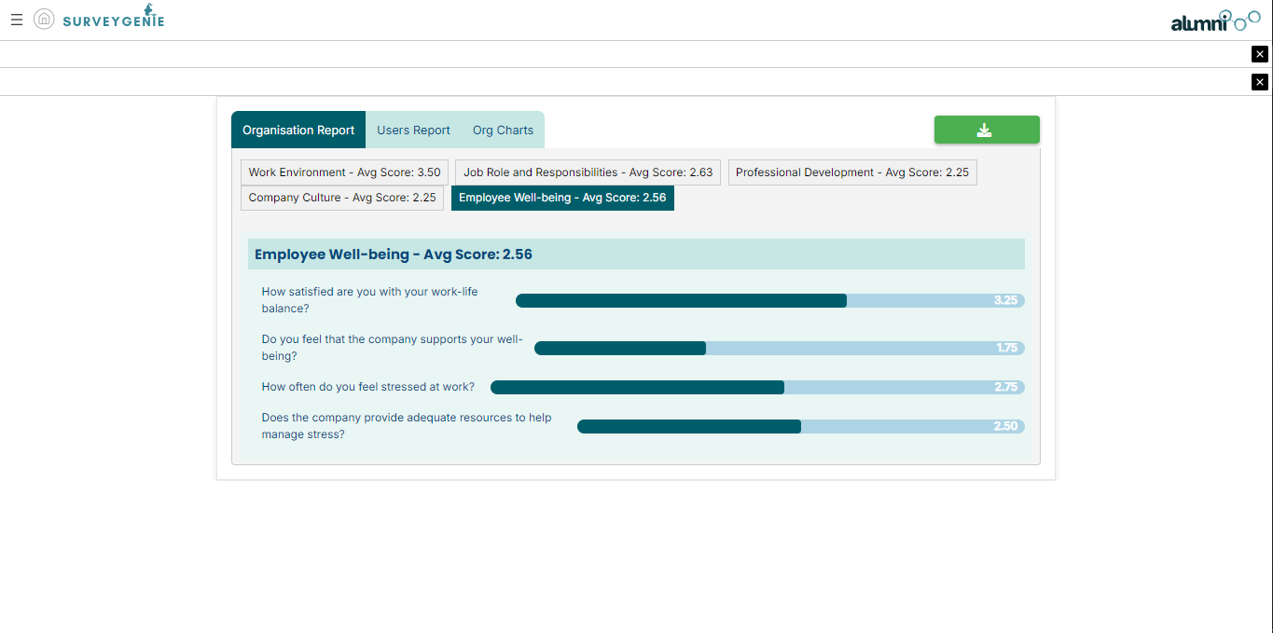

**3.13** **Guide to access BENCHMARK REPORT:**

1. Click on "Benchmark report" under “Report”.This report will be displayed only to users mapped to External admin and Super Admin roles and will not be visible to External Employees.
2. The report will display the standard values for all the surveys available in the application.
3. The values shown are average score against maximum average score.

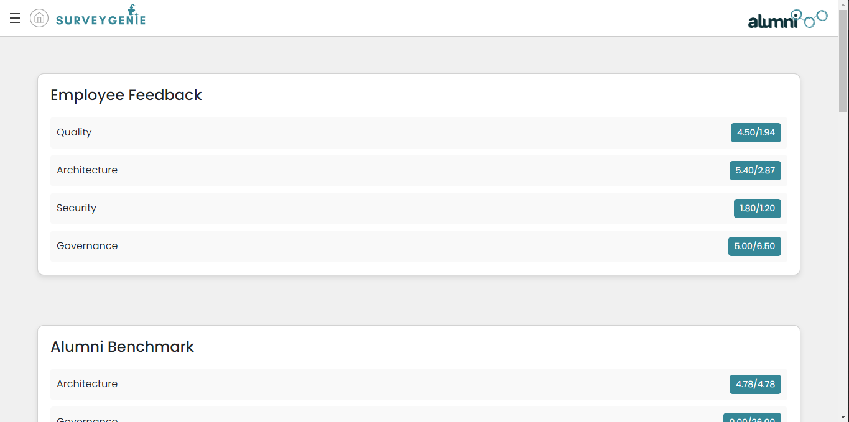

**3.14** **Guide to create RECOMMENDATION:**

1. Click on "Recommendation master” under “Recommendation”.
2. Click the “New” button on the top right corner of the grid.
3. Fill the required recommendation text in the field.
4. Click the “Save” button to create the recommendation.

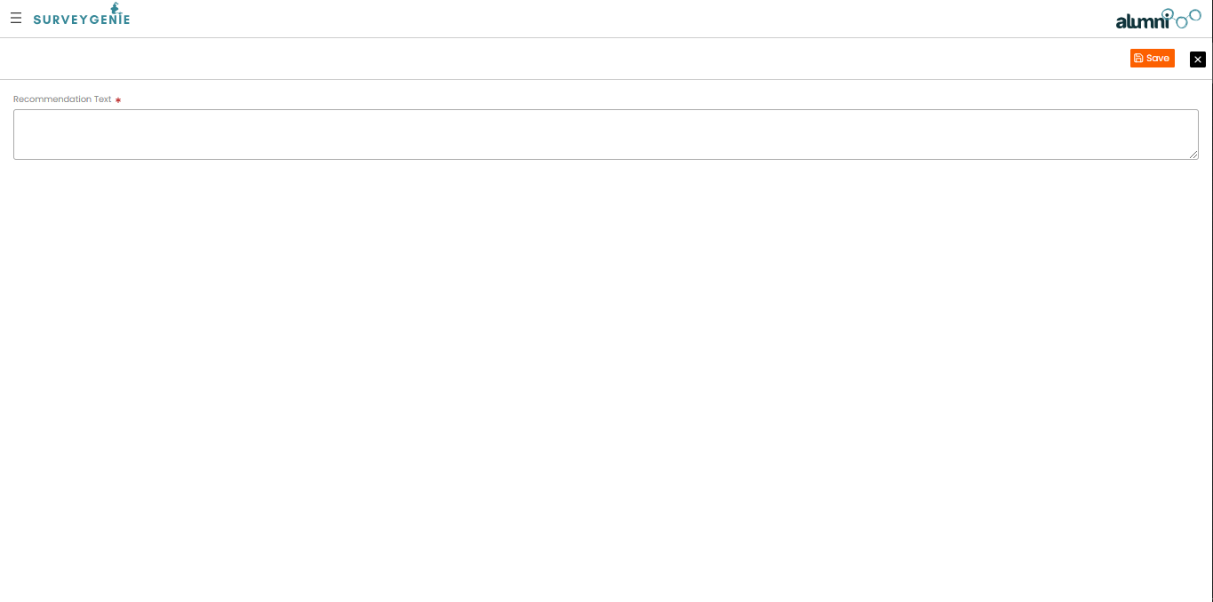

**3.15** **Guide to create SCORE-RANGE MASTER:**

1. Click on "Score Range Manager” under “Recommendation”.
2. Click on “New” on the top left corner of the grid.
3. Fill in the “Score set name”, “Score range from” and “Score set to” based on the range of the average.
4. Click on the “Save” button to create the score set.

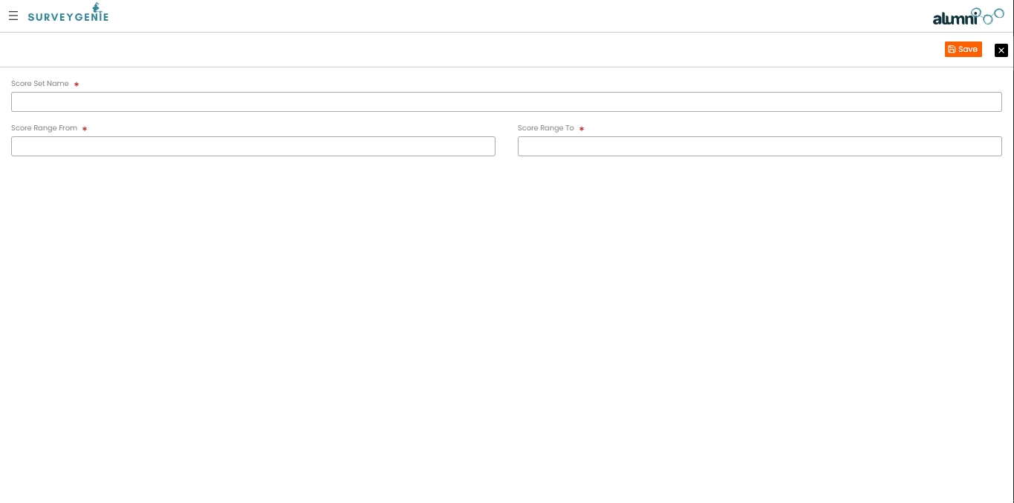

**3.16** **Guide to map SCORE-RANGE - RECOMMENDATION:**

1. Click on "Score Range Manager” under “Recommendation”.
2. Click the score set you want to map a recommendation to.
3. Click on the “Map recommendation” link below.
4. Click on the “New” button on the top left of the grid.
5. From the dropdown, pick the recommendation you want to map to the score set.
6. Click “Save” to save the mapping.

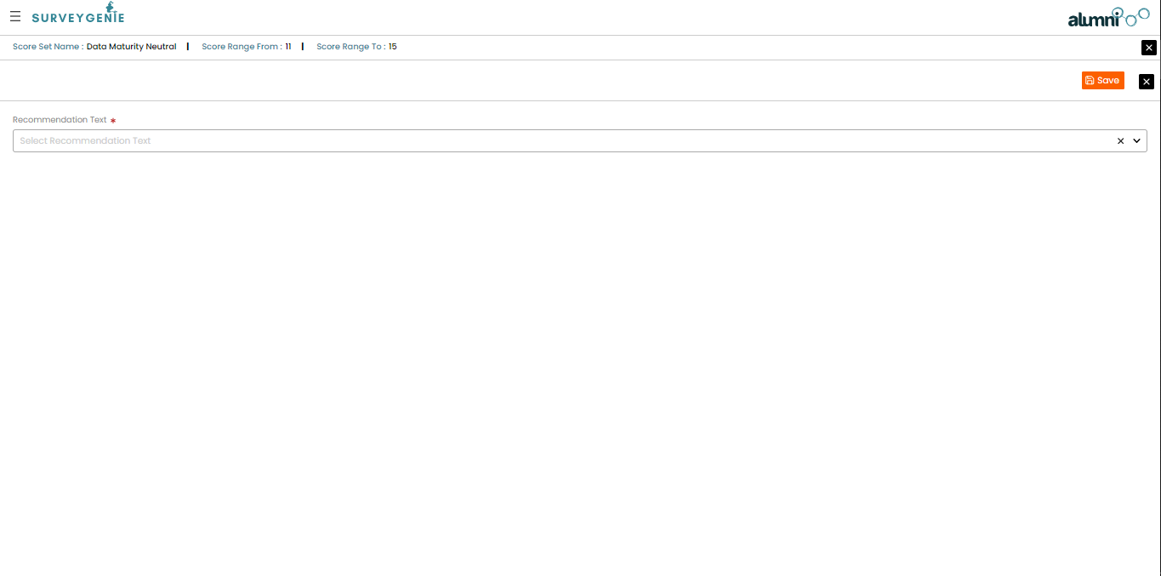

**3.17** **Guide to map CATEGORY - SCORE-RANGE:**

1. Click on "Level-1” under “Manage”.
2. Click the edit icon against the Level 1 which you want to map the score-set to.
3. Click the recommendation tab to access the mapping screen.
4. Click the plus icon against the score set in the left grid to map the recommendation to Level 1.

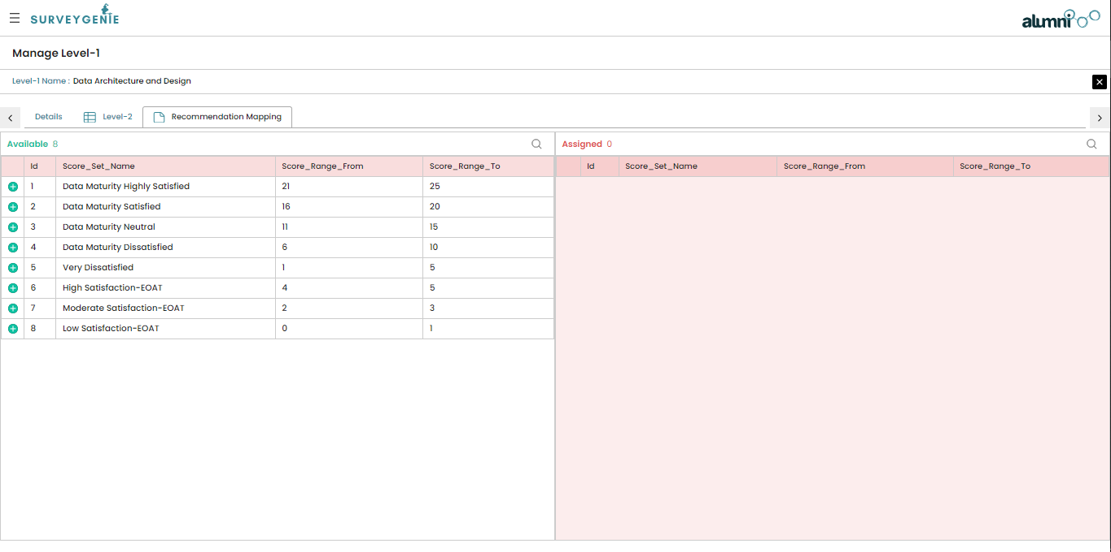

**3.18** **Guide to map SURVEY - SCORE-RANGE:**

1. Click on "Survey” under “Manage”.
2. Click the edit icon against the Survey which you want to map the score-set to.

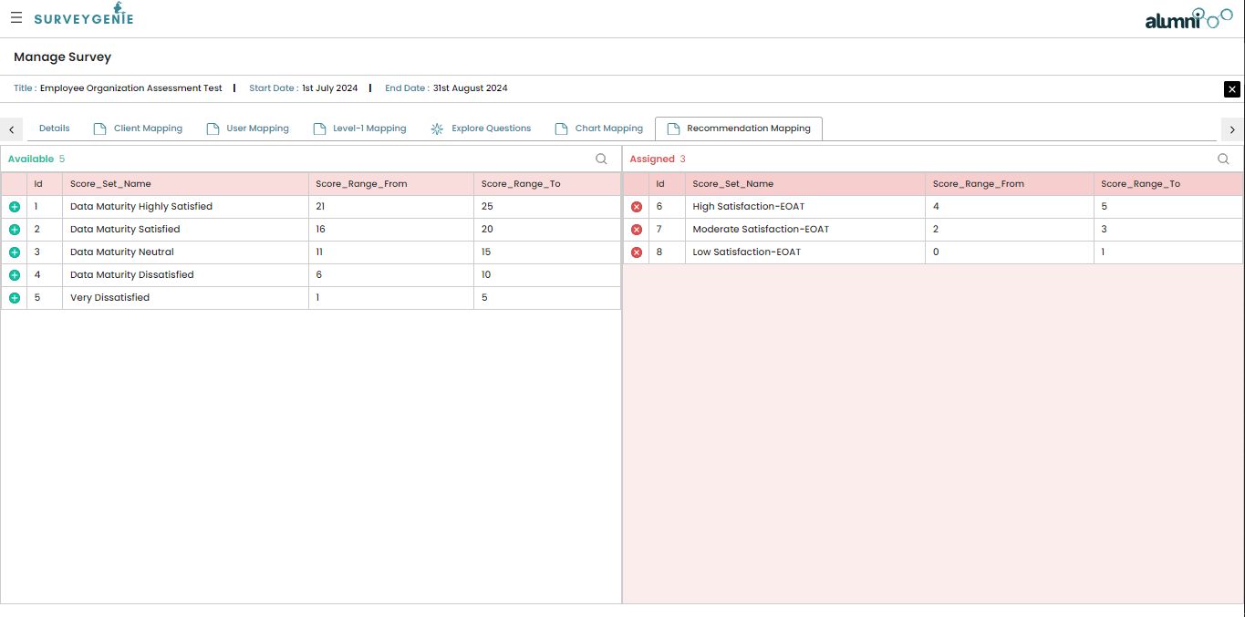

1. Click the recommendation tab to access the mapping screen.
2. Click the plus icon against the score set in the left grid to map the recommendation to Survey.

**3.19** **Guide to ANSWER THE QUESTIONS IN AN OPEN SURVEY:**

1. Enter the provided link in a browser.
2. From the list of surveys, click on the one you want to attend.
3. Click the Launch survey link.
4. Continue answering the questions as per the instructions in section 3.10.
5. After clicking on the next button in the final category, a partially visible report will be shown.
6. Click on the register button below and enter the data for the fields Full name, Title, Company name, Company size, and E-mail.

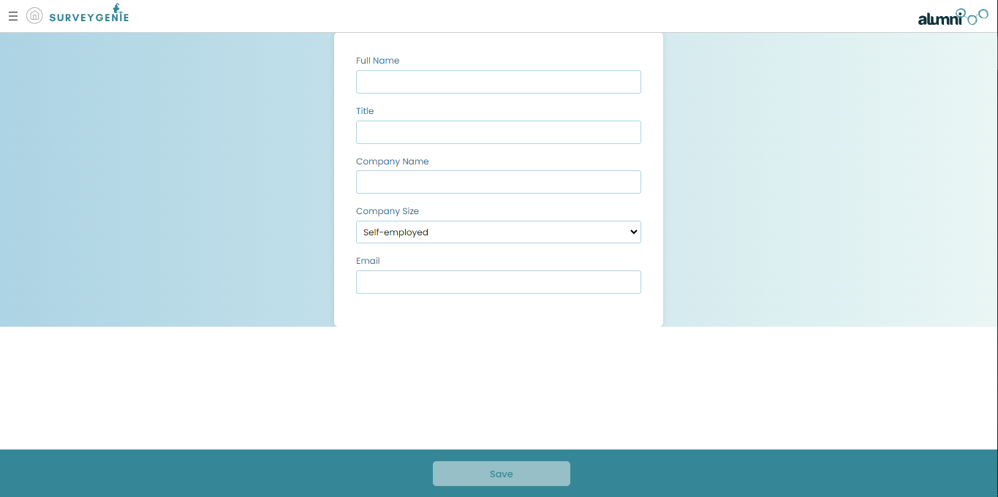

1. Click save and you will be able to see all the categories in the report and the charts of the associated attempt.

**3.20** **Guide to access OPEN SURVEY REPORT:**

1. Click on "Open Users List" under “Open Users”.This report will be displayed only to users mapped to Super Admin roles and will not be visible to External Employees and External Admins.
2. A list of all open users and their attempted surveys will be shown. Click on the entity that you want to view the result to.
3. Click the “View Report” Link.
4. The opened report will show the level-1, questions and the score attained by the open user against each question.
5. Click on the Charts tab to view the pictorial representation of the scores in the form of donut, bar and radial chart.

